

11

/B

-

47

M.YUSUF ÖZDOĞAN

*Nuvoton M031FB0AE*

*Geliştirme kartı tanıtım*

*dökümanıdır.*

Bu belge geliştirdiğimiz kartın özelliklerini temel düzeyde gösteren bir dokümandır.



*17.04.2023*

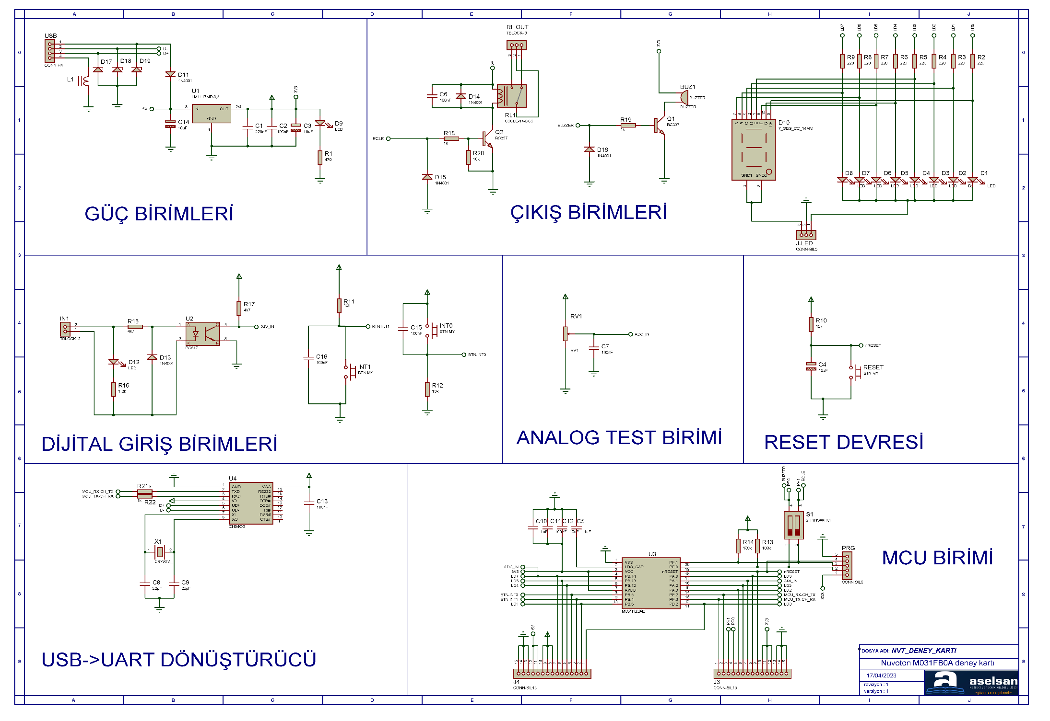

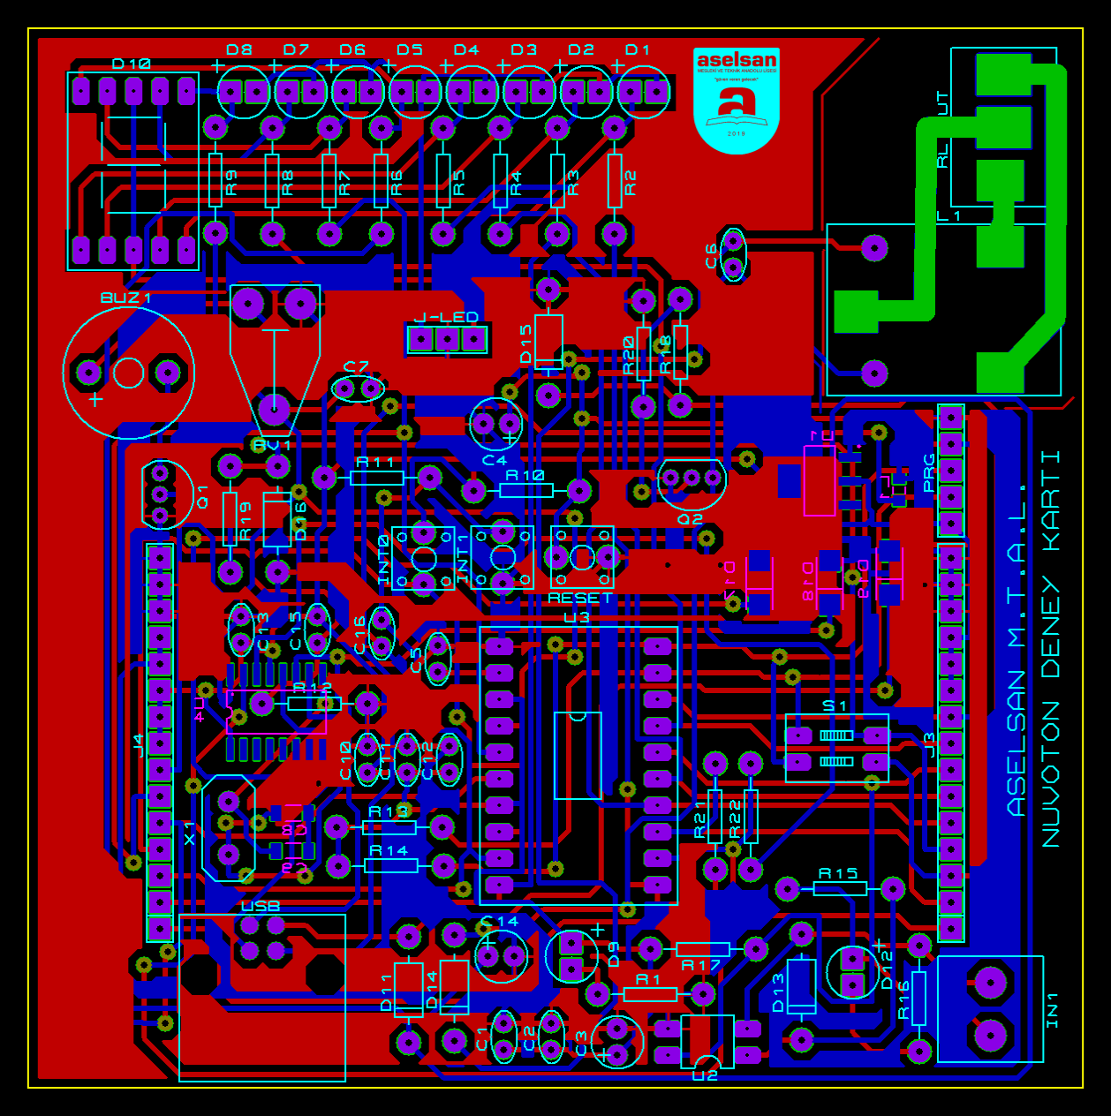

**GENEL BASKI DEVRE GÖRÜNÜŞÜ**

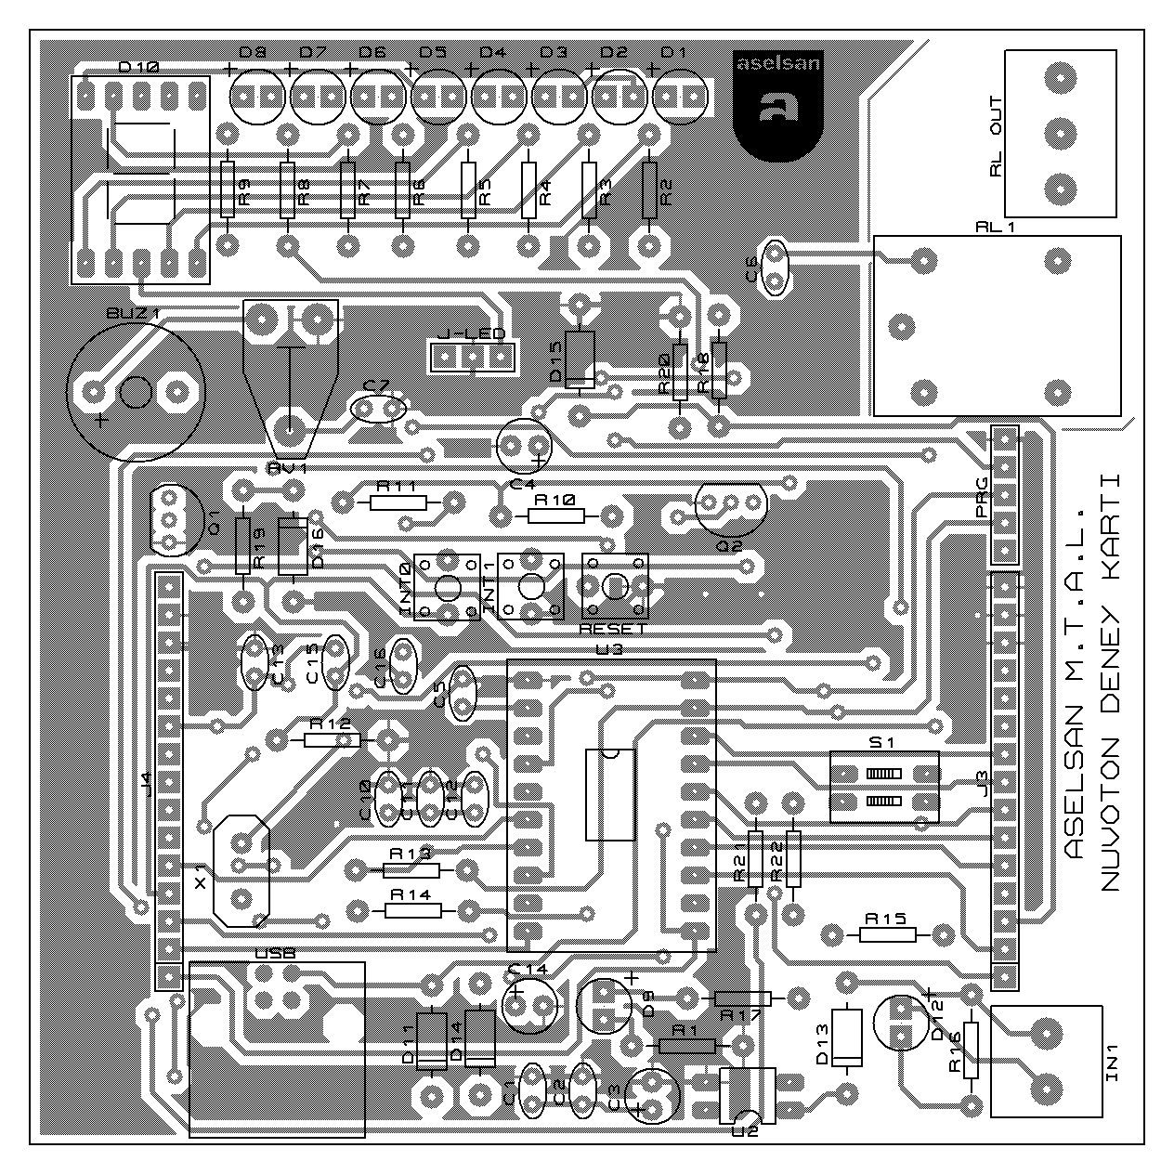

**ÜST KATMAN YERLEŞİM PLANI**

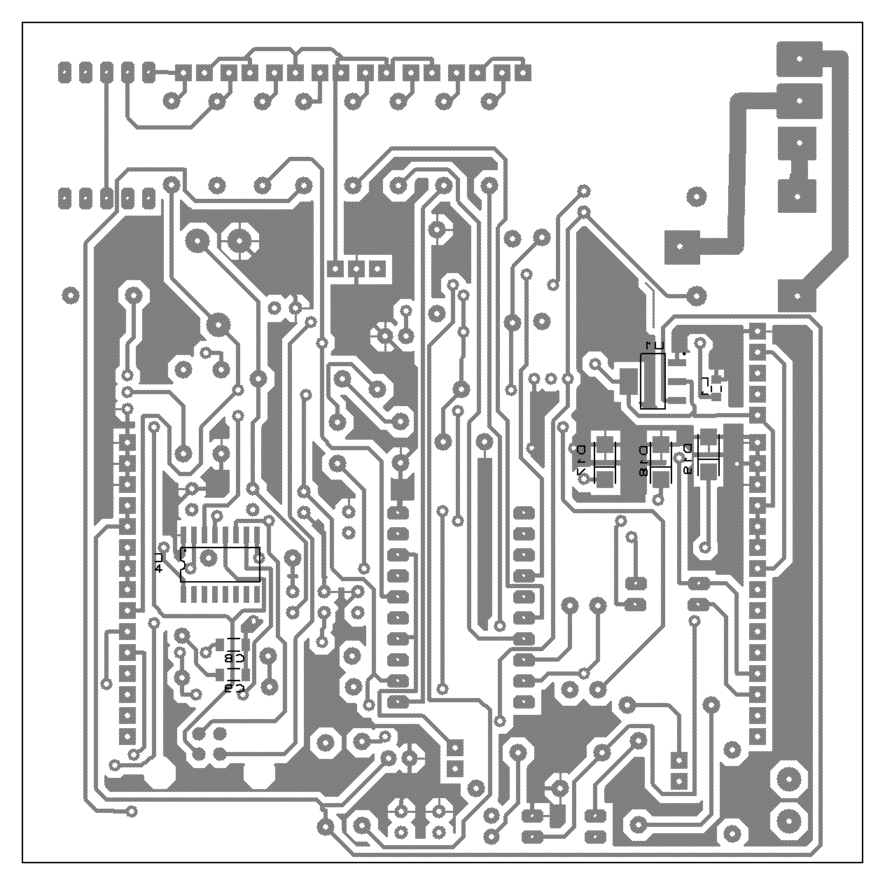

**ALT KATMAN YERLEŞİM PLANI**

|  |  |  |  |  |  |
| --- | --- | --- | --- | --- | --- |
| **Bill Of Materials for NVT_DENEY_KARTI_V1_REV2_6** | | | |  |  |
|  |  |  |  |  |  |
| **Design Title** | | | NVT_DENEY_KARTI_V1_REV2_6 | |  |
| **Author** | | |  | |  |
| **Document Number** | | |  | |  |
| **Revision** | | |  | |  |
| **Design Created** | | | 17 Nisan 2023 Pazartesi | |  |
| **Design Last Modified** | | | 17 Nisan 2023 Pazartesi | |  |
| **Total Parts In Design** | | | 79 | |  |
|  |  |  |  |  |  |
| **Category** | **Quantity** | **References** | **Value** | **PCB Package** |  |
| Capacitors | 1 | C1 | 220nF | CAP10 |  |
| Capacitors | 7 | C2,C6-C7,C11,C13,C15-C16 | 100nF | CAP10 |  |
| Capacitors | 3 | C3-C4,C14 | 10uF | ELEC-RAD10 |  |
| Capacitors | 2 | C5,C10 | 1uF | CAP10 |  |
| Capacitors | 2 | C8-C9 | 22pF | 1206 |  |
| Capacitors | 1 | C12 | 10nF | CAP10 |  |
| Resistors | 1 | R1 | 470 | RES40 |  |
| Resistors | 8 | R2-R9 | 220 | RES40 |  |
| Resistors | 4 | R10-R12,R20 | 10k | RES40 |  |
| Resistors | 2 | R13-R14 | 100k | RES40 |  |
| Resistors | 2 | R15,R17 | 4k7 | RES40 |  |
| Resistors | 1 | R16 | 1.2k | RES40 |  |
| Resistors | 4 | R18-R19,R21-R22 | 1k | RES40 |  |
| Integrated Circuits | 1 | U1 | LM1117MP-3,3 | SOT230P700X180-4 |  |
| Integrated Circuits | 1 | U2 | PC817 | DIL04 |  |
| Integrated Circuits | 1 | U3 | M031FB0AE | TSSOP-20 |  |
| Integrated Circuits | 1 | U4 | CH34OG | SOP16 |  |
| Transistors | 2 | Q1-Q2 | BC337 | TO92 |  |
| Diodes | 9 | D1,D3-D9,D12 | LED | LED |  |
| Diodes | 1 | D2 | D2 | LED |  |
| Diodes | 1 | D10 | 7_SEG_CC_14MM | 7SEG-MY |  |
| Diodes | 5 | D11,D13-D16 | 1N4001 | DO41 |  |
| Diodes | 3 | D17-D19 |  | DO214 |  |
| Miscellaneous | 1 | BUZ1 | BUZZER | BUZZER-MY-2 |  |
| Miscellaneous | 1 | IN1 | TBLOCK-I2 | TBLOCK-I2 |  |
| Miscellaneous | 3 | INT0-INT1,RESET | BTN MY | TOUCH_BUTTON_MY |  |
| Miscellaneous | 2 | J3-J4 | CONN-SIL15 | CONNSIL_15 MY |  |
| Miscellaneous | 1 | J-LED | CONN-SIL3 | CONN-SIL3 |  |
| Miscellaneous | 1 | L1 |  | 0805 |  |
| Miscellaneous | 1 | PRG | CONN-SIL5 | CONN-SIL5 |  |
| Miscellaneous | 1 | RL1 | G5CLE-14-DC5 | RLY-OMRON-C4 |  |
| Miscellaneous | 1 | RL OUT | TBLOCK-I3 | TBLOCK-I3 |  |
| Miscellaneous | 1 | RV1 | RV1 | PRE-HMIN |  |
| Miscellaneous | 1 | S1 | 2_PiNSWiTCH | SWITCHBEN |  |
| Miscellaneous | 1 | USB | CONN-H4 | USB-B |  |
| Miscellaneous | 1 | X1 | CRYSTAL | XTAL18 |  |
|  |  |  |  |  |  |

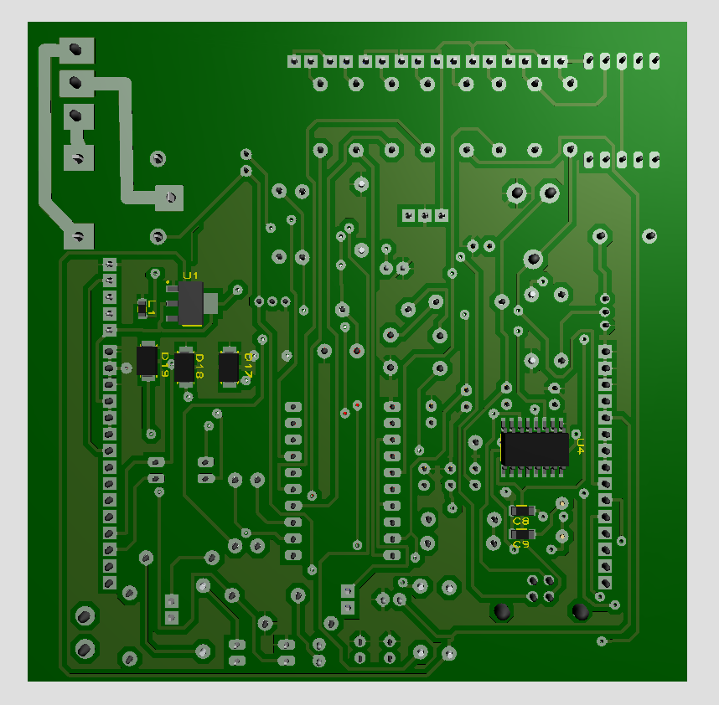

**ALT KATMAN 3D GÖRÜNTÜ**

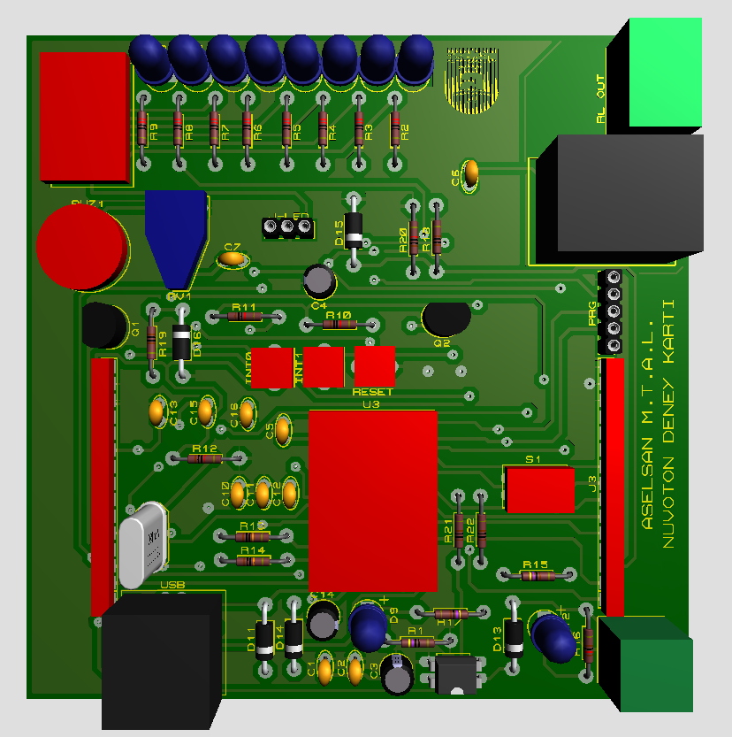

**ÜST KATMAN 3D GÖRÜNTÜ**